**Recursive Descent Parser**



 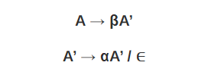

1. **S S0S1S | 01**

**S->01S’**

**S’->0S1S |Ꞓ**

**Left Factoring**

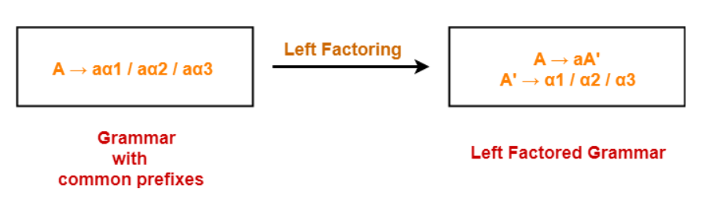

1. **A → aAB / aBc / aAc**

**A->aA’**

**A’->AB| Bc | Ac**

**A’-> AA’’ |Bc**

**A’’->B |c**

1. **A → aAB / aBc / aAc**

**A->aA’**

**A’->AB| Bc | Ac**

**A’-> AA’’ |Bc**

**A’’->B |c**

**E->E+T | T**

**E->TE’**

**E’->+TE’|+T**

**T->T*F | F**

**T->FT’**

**T’->*FT’|^**

**S-->S a / S b / c / d**

**S->cS’ | dS’**

**S’->aS’ |bS’ |Ꞓ**

S → a|^|(T)

T → T, S|S

S → a|^|(T)

**T->T,S|** a | ^ |(T)

**T->aT’ |^T’ |(T)T’**

**T’->, ST’ | null**

**S->abD| abB| abE| a|b**

**S->abS’| a|b**

**S’->D | B|E**

**Computation of First and Follow**

**E→TE’**

**E’ → +TE’|ε**

**T → FT’**

**T’ → *FT’|ε**

**F →(E)**

**F → id**

|  |  |  |
| --- | --- | --- |
|  | **First** | **Follow** |
| **E→TE’** | **{(, id}** | **{$,)}** |
| **E’ → +TE’|ε** | **{+, ε}** | **{$,)}** |
| **T → FT’** | **{(, id}** | **{First(E’)}**  **{+,$,)}** |
| **T’ → *FT’ | ε** | **{*, ε}** | **{+, $, )}** |
| **F →(E) |id** | **{ (, id}** | **{*,+,$,) }** |

1. **S->ABCDE**

**A->a |Ꞓ**

**B->b |Ꞓ**

**C->c**

**D-> d | Ꞓ**

**E-> e |Ꞓ**

|  |  |  |
| --- | --- | --- |
|  | **First** | **Follow** |
| **S->ABCDE** | **{a,b,c}** | **{$}** |
| **A->a |Ꞓ** | **{a, Ꞓ}** | **{b,** |
| **B->b |Ꞓ** | **{b, Ꞓ}** |  |
| **C->c** | **{c}** |  |
| **D-> d | Ꞓ** | **{d, Ꞓ}** |  |
| **E-> e |Ꞓ** | **{e, Ꞓ}** |  |
|  |  |  |

1. **S-> Bb | Cd**

**B->aB |Ꞓ**

**C->cC |Ꞓ**

|  |  |  |
| --- | --- | --- |
|  | **First** | **Follow** |
| **S-> Bb | Cd** | **{a,b,c,d}** |  |
| **B->aB |Ꞓ** | **{a, Ꞓ}** |  |
| **C->cC |Ꞓ** | **{c, Ꞓ}** |  |

1. **S->ACB | CbB | Ba**

**A-> da |BC**

**B ->g|Ꞓ**

**C->h|Ꞓ**

**Top Down Parser**

**E->E+T | T**

**T->T*F | F**

**F →(E) |id**

**E->TE’**

**E’->+TE’|Ꞓ**

**T->FT’**

**T’->*FT’ |Ꞓ**

**F →(E) |id**

|  |  |  |
| --- | --- | --- |
|  | **First** | **Follow** |
| **E→TE’** | **{(, id}** | **{$,) }** |
| **E’ → +TE’ | ε** | **{+ , ε}** | **{$,) }** |
| **T → FT’** | **{(, id}** | **{+,$,)}** |
| **T’ → *FT’ | ε** | **{*, ε}** | **{+,$,)}** |
| **F →(E) |id** | **{ (, id}** | **{*,+,$,)}** |

**Predictive Parsing Table M[X,a]**

|  |  |  |  |  |  |  |
| --- | --- | --- | --- | --- | --- | --- |
| **M[X,a]** | **id** | **+** | **\*** | **(** | **)** | **$** |
| **E** | **E→TE’** |  |  | **E→TE’** |  |  |
| **E’** |  | **E’ → +TE’** |  |  | **E’->ε** | **E’-> ε** |
| **T** | **T → FT’** |  |  | **T → FT’** |  |  |
| **T’** |  | **T’-> ε** | **T’ → *FT’** |  | **T’-> ε** | **T’-> ε** |
| **F** | **F->id** |  |  | **F →(E)** |  |  |

**Moves by predictive parser**

|  |  |  |
| --- | --- | --- |
| **Stack** | **Input** | **Ouput** |
| **$E** | **id+id*id$** |  |
| **$E’T** | **id+id*id$** | **E→TE’** |
| **$E’T’F** | **id+id*id$** | **T → FT’** |
| **$E’T’id** | **id+id*id$** | **F->id** |
| **$E’T’** | **+id*id$** |  |
| **$E’** | **+id*id$** | **T’-> ε** |
| **$E’T+** | **+id*id$** | **E’ → +TE’** |
| **$E’T** | **id*id$** |  |
| **$E’T’F** | **id*id$** | **T → FT’** |
| **$E’T’id** | **id*id$** | **F->id** |
| **$E’T’** | **\*id$** |  |
| **$E’T’F\*** | **\*id$** | **T’ → *FT’** |
| **$E’T’F** | **Id$** |  |
| **$E’T’id** | **Id$** | **F->id** |
| **$E’T’** | **$** |  |
| **$E’** | **$** | **T’-> ε** |
| **$** | **$** | **E’-> ε** |

**S->iCtSE | a**

**E->eS | Ꞓ**

**C->b**

|  |  |  |
| --- | --- | --- |
|  | **First** | **Follow** |
| **S->iCtSE | a** | **{i,a}** | **{$,e}** |
| **E->eS | Ꞓ** | **{e, Ꞓ}** | **{$,e}** |
| **C->b** | **{b}** | **{t}** |

|  |  |  |  |  |  |  |
| --- | --- | --- | --- | --- | --- | --- |
|  | **a** | **b** | **e** | **i** | **t** | **$** |
| **S** | **S->a** |  |  | **S->iCtSE** |  |  |
| **E** |  |  | **E->eS**  **E->Ꞓ** |  |  | **E->Ꞓ** |
| **C** |  | **C->b** |  |  |  |  |

**Construct a predictive parsing table for the following grammar with**

**S -> S(S)S | ε with input (()())**

**S-> εS’**

**S’->(S)SS’ | ε**

**S-> S’**

**S’->(S)SS’ | ε**

**Frist and Follow**

**First(S)={(, ε} Follow(S)={$,)}**

**First(S’)={(, ε} Follow(S’)= {$,)}**

|  |  |  |  |
| --- | --- | --- | --- |
|  | **(** | **)** | **$** |
| **S** | **S-> S’** | **S-> S’** | **S-> S’** |
| **S’** | **S’->(S)SS’** | **S’-> ε** | **S’-> ε** |

|  |  |  |
| --- | --- | --- |
| **Stack** | **Input** |  |
| **$S** | **(()())$** |  |
| **$S’** | **(()())$** | **S-> S’** |
| **$S’S)S(** | **(()())$** | **S’->(S)SS’** |
| **$S’S)S** | **()())$** |  |
| **$S’S)S’** | **()())$** | **S-> S’** |
| **$S’S)S’S)S(** | **()())$** | **S’->(S)SS’** |
| **$S’S)S’S)S** | **)())$** |  |
| **$S’S)S’S)S** | **)())$** | **S-> S’** |
| **$S’S)S’S)S’** | **)())$** |  |
| **$S’S)S’S)** | **)())$** | **S’-> ε** |
| **$S’S)S’S** | **())$** |  |
|  |  |  |
|  |  |  |
|  |  |  |
| **$** | **$** | **Accept** |